Inspire - Substance and Misuse Service
Inspire are part of the National Charitable Organisation ‘Change Grow Live’. Their aim is to provide recovery from addiction and dependence and support people to make positive changes to their lives.
Inspire covers the whole of Lancashire, and the North & Central Service includes hubs in Preston, Chorley and Skelmersdale. They provide all aspects of drug and alcohol treatment in Lancashire, including open access, structured treatment and referral to Tier 4 rehabilitation.
Referral can be made either by a professional or as a self-referral using the same brief referral form.
For any queries regarding medication, Inspire can be contacted on 08081698673 and there is an option to speak to the Prescribing Administration Team.
Smokefree Lancashire
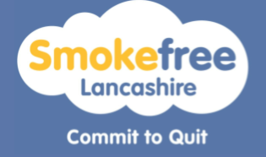
Inspire have also recently taken over the contract for stopping smoking from Quitsquad and the new Smokefree Lancashire’s website is now live. Patients can be referred online by a professional or as a self-referral.

Useful links

www.changegrowlive.org
www.inspirelancs.org.uk
www.smokefreelancashire.org.uk

To contact the Medicines Optimisation Team please phone 01772 214302
If you have any suggestions for future topics to cover in our prescribing tips please contact Nicola.schaffel@nhs.net
All content accurate and correct on the date of issue of this tip.

